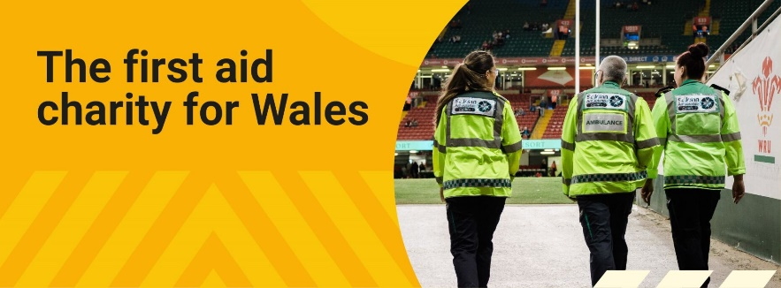

Hospitaller

Volunteer Role

Pan Wales

|  |  |
| --- | --- |
| **Role Purpose:** | To be the principal link between the Priory for Wales and the St John Eye Hospital Group, as well as leading the St John Eye Hospital Panel responsible for raising both funds and awareness to support the critical work of the St John Eye Hospital Group, in partnership with the St John Councils, the wider Priory, senior volunteers and the Order Affairs Administrator. |
| **Potential time commitment:** | The nature of the role requires the Hospitaller to work evenings and weekends on occasion to attend functions, events and meet volunteers, divisions and St John Councils across Wales. |
| **Location:** | Pan-Wales with the requirement to travel whenever the need arises and to attend events, meetings or any other business of the Priory for Wales. Reasonable travelling and subsistence payments will be made in accordance with SJAC Policy. |
| **Responsible to:** | Registrar. |
| **Responsible for:** | St John Eye Hospital Panel. |
| **This role involves:** | * To promote the profile and visibility across Wales of the St John Eye Hospital Group and its vital humanitarian work. * To organise fundraising activities and events for the St John Eye Hospital Group in line with the targets set by the temporal Great Officers of the Priory for Wales (Prior, Chancellor and Bailiff of St Davids). This is to include but is not limited to the Christmas Carol Service held each year in the Priory Church in Cardiff. * To regularly liaise with the Fundraising team of St John Ambulance Cymru to ensure that St John Eye Hospital Group fundraising activities are harmoniously planned and organised alongside other fundraising and promoting activities. * To Chair the Eye Hospital Panel, ensuring it is sufficiently resourced, effectively functioning, has working Terms of Reference and a membership which supports the full breadth of the communities of Wales served by the Priory, encouraging equality, diversity and inclusion throughout. * To use a facilitative management approach to recruit, coach, mentor, develop and coordinate a sufficient and appropriate team, including the members of the Eye Hospital Panel, that is able to plan, communicate and deliver effective fundraising and promotional events, including:   + ensuring instructions have been agreed by all appropriate stakeholders ahead of events;   + ensuring the team are able to coordinate planning, logistics and all aspects of the events in a fully self-sufficient manner, maintaining high standards throughout;   + planning arrangements for dignitaries throughout events, with due regard for their time constraints and other limitations and requirements; and   + promoting equality, diversity and inclusion to ensure that the team is representative of the full breadth of the communities of Wales served by the Priory. * To coordinate with the St John Councils in Wales to ensure events and activities are complementary with fundraising in their respective areas and to assist the St John Councils in promoting and supporting the St John Eye Hospital Group in turn. * To provide update reports on the St John Eye Hospital Group at least quarterly to Priory Chapter, as well as writing a more extensive annual report with images where possible on its activities over the past year for inclusion in the annual report of St John Ambulance Cymru. * To establish and maintain relationships with the St John Eye Hospital Group, including:   + regular contact with the St John Eye Hospital Group UK officer based in London;   + regular contact with the CEO of the St John Eye Hospital Group based in East Jerusalem, usually by means of a monthly online videoconference call;   + regular contact with the Hospitaller of the Order of St John; and   + joining the annual St John Eye Hospital Group Symposium in London. * Where practical, safe and sanctioned by the Great Officers of the Priory, to visit the St John Eye Hospital Group in East Jerusalem, the West Bank and/or Gaza * To ensure that all those overseen hold a valid safeguarding qualification and an accepted valid DBS certificate, and that they attend the requisite safeguarding, health and safety, wellbeing and other identified relevant training as required. |
| **Training and Support:** | Leadership training will be provided.  Support will be provided by: the Chancellor |
| **What you will get from this role:** | • Have input to create positive change in how we fundraise and raise the profile of the Eye Hospital of Jerusalem  • Direct and support effective fundraising for the Eye Hospital of Jerusalem  • Make significant impact on the communities of war-torn Gazza  • Meet and collaborate with a wide variety of people and professionals from various backgrounds across Wales.  • Lead and motivate a panel of fundraisers through fundraising events, ensuring they have the resources and skills to succeed.  • Be part of an inclusive and diverse organisation. |

11

|  |  |  |  |  |  |
| --- | --- | --- | --- | --- | --- |
| **What you will need for the role** |  | **Required** |  | **Required** | **Desirable** |
| **All volunteer leaders require:** | A valid Group B Safeguarding qualification and an accepted valid DBS certificate | P | Experience of managing teams and resources in a manner consistent with a culture of accountability, professionalism and excellence in service delivery | P |  |
| Understanding of and commitment to our organisational vision, mission and purpose | P | Understanding of the role of the volunteer and the opportunities and challenges this can create | P |  |
| Clear understanding of and commitment to our people, safety, operations and clinical policies / practices | P | Ability to professionally represent the organisation at local and national engagements | P |  |
| Absolute commitment to role modelling our values at all times and helping others to do the same | P | Excellent interpersonal skills and the ability to communicate and influence others at all levels | P |  |
| Willingness and ability to devote the time and effort required to fulfil the role to a high standard | P |  |  |  |
|  | | | | |  |
| **In addition, this role requires** | Substantial fundraising experience, able to win hearts and minds to maximise voluntary giving to support the St John Eye Hospital Group. | P | Commitment to devote sufficient time and effort behind the scenes to planning in advance and meaningful debrief after each and every event. | P |  |
| Networking and influence, with the ability to maximise awareness and fundraising reach in support of the St John Eye Hospital Group. | P | Ability to plan and manage complex workloads, deadlines and risks. | P |  |
| Enthusiastic leadership skills, remaining approachable, confident and compassionate, and understanding the volunteer ethos of the Order and Priory. | P | Ability to think creatively, organise diligently and prioritise effectively. | P |  |
| Planning and organisational skills and experience. | P | Experience or interest in ophthalmology. |  | ✓ |
| Oratory, communication and presentation skills. | P | Experience in a clinical setting or organisation. |  | ✓ |
| Diplomatic skills, able to anticipate and assuage the needs of dignitaries and guests of the Priory before, during and after events. | P | Arabic language experience. |  | ✓ |
| Attention to detail to ensure that plans are accurate and up-to-date, and that the team delivers highly professional events with every aspect carefully planned. | P | Welsh language experience. |  | ✓ |

|  |  |
| --- | --- |
| **St John Ambulance Cymru Values:**  We ask that all St John People uphold and model our Values | We value **Compassion -** we are caring, unselfish and supportiveWe value **Quality -**we are reliably delivering the highest standardsWe value **Inclusion -**we are respectful, we welcome diversity and work locally, nationally and internationallyWe value **Integrity -**we are open, honest and trustworthy |
| **Health, Safety and Welfare and Safeguarding:** | Adhere to the health and safety policies, procedures, and regulations of St John Ambulance Cymru, along with relevant statutory requirements. Prioritise the health, safety, and well-being of both St John Ambulance Cymru members and the public they interact with. Additionally, uphold St John Ambulance Cymru’s safeguarding duties and responsibilities by ensuring complete compliance with all safeguarding training, policies, and procedures. This role requires a minimum valid Group B Safeguarding qualification and an accepted valid DBS certificate. |

**\* In line with ‘Strategy 2025/30 - People, Experience & Culture’ this role will be a non-ranked uniform role.**

**\* * This appointment will be for an initial three-year term, with the possibility of an additional three years, however this role will not be extended past six years.**